CSE 483

**Final Project – Spring 2017**

**Homework Objective**: Provide the students an opportunity to demonstrate knowledge learned throughout the semester, specifically in the following area: C# Programming, WPF Application Development, Data Binding, Observable Collections, .NET Threads, .NET Timers, .NET UDP Sockets, .NET Events, 3rd Party DLL’s

**Remotely Settable Digital Alarm Clock**

1. You are to develop a WPF Digital Alarm Clock. This clock will display Hours, Minutes and Seconds
2. The clock will increment each second, using a .NET timer.
3. The clock will be initialized with the current time at application startup, but will be incremented manually by the 1 second timer. As the seconds roll over, you will increment the minutes. As the minutes roll over, you will increment the hours.
4. Your Alarm Clock will have the ability to set an Alarm time. When the clock time equals the alarm time, an Event will be fired to cause an Alarm indication, similar to the picture below.
5. Your Digital Alarm Clock may look something like this:

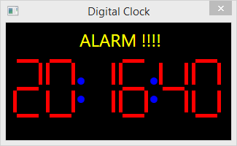

1. You will also develop another WPF application that will allow the user to update the time.
2. The user can manually enter hour, minute, and second, or they can just update the Digital Clock to the current time. The Alarm is set by the Set Alarm button.
3. This application may look something like this:

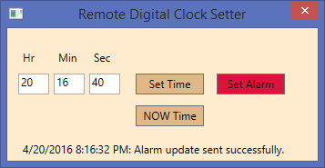

1. When the Set Time button is pressed, the clock will be updated to the time entered. Input must be checked! That is, if the user enters an invalid time, it must be ignored.
2. When the NOW Time button is pressed, the clock will be updated with the current time.
3. When the Set Alarm button is set, the alarm on the clock will be set.
4. Groups of up to 3 will be allowed, with the following conditions:
   1. Groups of 3 MUST implement all requirements, with a max score of 100.
   2. Groups of 2 MUST implement all requirements, with a max score of 120.
5. To receive full credit, your applications, cumulatively, must demonstrate all required components outlined in the statements above, including the following:
   1. .NET Threads
   2. .NET Events
   3. .NET UDP Sockets
   4. .NET Timer
   5. Data Binding
   6. Observable Collection
   7. Use of 3rd Party DLL

**Provided Materials:**

To help you complete this project in the time allotted, and in the most efficient manner, the following materials are provided for you on the Blackboard. These materials can be found on the Content page, under Final Project Supplements.

1. XAML for the Digital Clock application. This XAML provides you with the basic window, and the UI element required for a single 7-Segment LED. Note that in the sample shown above, there are 6, 7-Segement LEDs. This XAML may need to be adapted for your application.
2. TimeDataDLL. This DLL provides an object which contains the data that can be sent over a UDP socket by the Remote Digital Clock Setter application. In terms of an in-class example, this data would take the place of the GameData structure that was defined in the UDP Peer sample project. The data MUST be located in a shared DLL in order for it to be serialized and de-serialized by 2 separate C# assemblies. This DLL can be used as-is. To use this DLL, simply add a Reference to the DLL in your projects, and refer to the data type as TimeData.StructTimeData. This data contains the following:

* int StructTimeData.hour
* int StructTimeData.minute
* int StructTimeData.second
* bool StructTimeData.isAlarmTime

**Format:** Provide the information as follows:

1. Zip project files.
2. Upload the zip file via the web to the Blackboard.
3. Please include all team member names as part of the header in each source file.
4. Please append _FinalProject_GroupN to the .zip file name, where N is your Group letter.